|  |  |  |  |
| --- | --- | --- | --- |
| **Name of Student: NINAD AVINASH PATIL** | | | |
| **Roll No: 33** | | **Lab Practical Number: 4(D)** | |
| **Title of Lab Practical: Create ASP.NET MVC application.** | | | |
| **DOP: 06/04/2021** | | **DOS: 14/04/2021** | |
| **CO Mapped: CO1** | **PO Mapped: PO3, PO5, PO7,**  **PO12, PSO1, PSO2** | **Faculty Signature:** | **Marks:** |

**Practical No 4(D)**

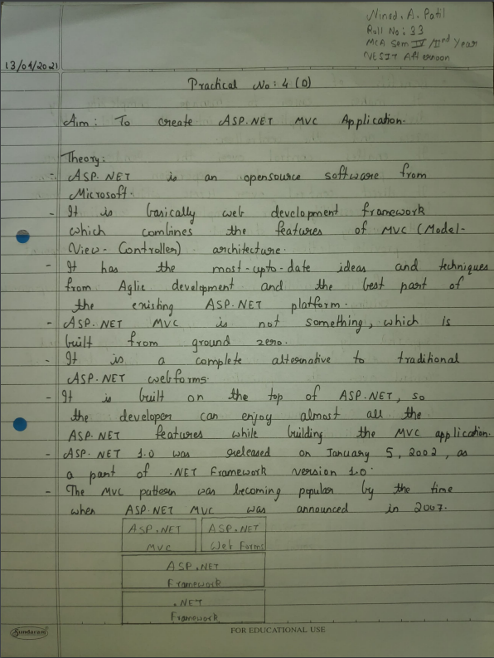

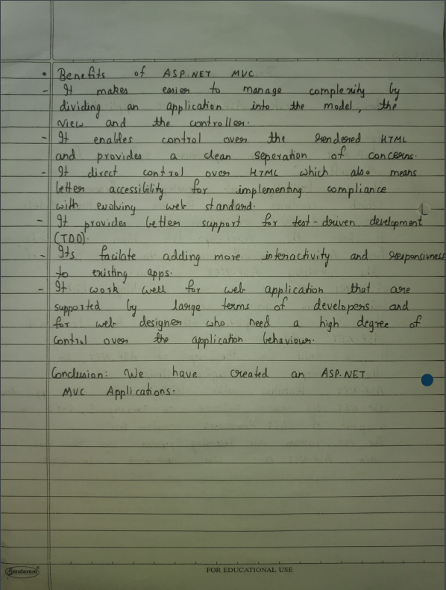

**Code:**

**HomeController.cs**

using System;

using System.Collections.Generic;

using System.Linq;

using System.Web;

using System.Web.Mvc;

namespace P4D.Controllers

{

[HandleError]

public class HomeController : Controller

{

public string Index()

{

return "Welcome To ASP.NET MVC Application";

}

}

}

**Output:**

